# Кредитний модуль

**«Компоненти програмної інженерії - 1. Моделювання і Аналіз вимог до програмного забезпечення»**

**Спеціальність 121 «Інженерія програмного забезпечення»**

**Освітня програма Інженерія програмного забезпечення комп’ютеризованих систем**

**Форма навчання денна**

**2022-2023**

**Модульна Контрольна Робота**

**Група ІП-12**

**Студент Кушнір Ганна Вікторівна**

**Тема Модульної Контрольної Роботи:**

Моделювання та аналіз вимог до програмного забезпечення на прикладі автоматизації Бізнес-процесу “Доставка товарів”

**Практичне моделювання та специфікування вимог до програмного забезпечення**

1. **Етапи моделювання та специфікування вимог до програмного забезпечення.**

Процес моделювання та специфікування вимог до програмного забезпечення складається із наступних етапів:

1. *Виявлення вимог до розроблюваної системи (Identification and Analysis of Requirements).*

Після обговорення потреб та побажань замовника напряму із самим замовником, бізнес-аналітик детально занотовує всі важливі компоненти та кроки Бізнес-процесу, що автоматизується. Це робиться для того, щоб при побудові моделі системи, яка буде передана на розробку, аналітик мав основу (так званий «фундамент»), за яким поступово він буде вибудовувати все більш і більш точні специфікації. Правильність виявлення вимог на даному етапі визначає, наскільки точно буде проведена подальша їх деталізація, з якою повинні будуть працювати девелопери. Неточності, що виникли в результаті роботи на етапі виявлення вимог до розроблюваної системи, можуть призвести (і майже точно призведуть) до невідповідності розробленого програмного забезпечення потребам стейкхолдерів. Кінцевим результатом цього етапу є текстовий опис визначених вимог.

1. *Моделювання Варіантів Використання (Use Cases Modeling).*

Серед кроків бізнес-процесу, що були описані у вимогах, виявлених на попередньому етапі, обираються такі, що виконуються безпосередньо у системі (такі як, встановлення певного статусу замовлення, закриття замовлення і т.д.). Ці кроки подаються на діаграмі Use Cases Diagram у вигляді окремих Use Case-ів (варіантів використання системи, тобто дій, що можуть виконуватися у системі), які поєднуються між собою за допомогою різних типів зв’язків. На даній діаграмі також зображуються виконавці цих дій. Діаграма Use Cases будується для того, щоб відобразити, які саме дії будуть виконуватися у системі і які операції потрібно буде потім реалізувати в програмному забезпеченні. Зрозуміло, що результатом даного етапу моделювання вимог буде діаграма варіантів використання.

1. *Моделювання Бізнес-процесу (Business Process Modeling).*

На даному етапі змодельовані раніше варіанти використання подаються у вигляді послідовних дій (потоку подій), що виконуються впродовж Бізнес-процесу, що моделюється. Призначення цього етапу – продемонструвати, які дії повинні бути реалізовані в системі, і в якому порядку вони повинні будуть виконуватися. Результатом проведення моделювання Бізнес-процесу є графічна діаграма, що відображає безпосередньо перебіг подій досліджуваного Бізнес-процесу.

1. *Моделювання Екранних форм Бізнес-процесу (Screen Forms Modeling).*

Проводиться аналіз побудованої діаграми Бізнес-процесу і на його основі визначаються графічні елементи, які повинні бути зображені на Екранних формах для можливості відтворення послідовності дій, що виконуються впродовж даного процесу. Також на цьому етапі визначається, яким саме чином дані відображаються на Екранних формах і як саме з ними можуть взаємодіяти користувачі. Отже, даний етап має на меті специфікацію конкретного інтерфейсу майбутнього програмного забезпечення, а також детальний опис методів формування даних на Екранних формах Бізнес-процесу і те, як з цими даними працює користувач ПЗ. Також на цьому етапі при визначенні методів формування даних на Екранних формах згадуються елементи Бази даних, що будуть детально описані на наступному етапі.

1. *Моделювання даних Бізнес процесу (Data Modeling).*

Призначення даного етапу – сформувати схему Бази даних, яка буде використана девелопером або ж DBA (адміністратором БД) безпосередньо при реалізації самої Бази даних, у якій будуть зберігатися всі дані, що використовуються у Бізнес-процесі. Моделювання даних тут являє собою побудову діаграми класів, що складається з інформаційних об’єктів системи, що автоматизується. Іншими словами – діаграми, елементами якої є таблиці Бази даних, кожна з яких має свої атрибути та операції, які можуть над нею (таблицею) виконуватися. Отже, результатом роботи на даному етапі є діаграма класів (Class Diagram).

1. *Моделювання User Stories Екранних форм (User Stories Description).*

Даний етап складається із детального опису кінцевих вимог до програмного забезпечення, сформованих на основі попередніх двох етапів. Мається на увазі, що тут описуються вимоги до візуального представлення Екранних форм, а також до можливостей їх функціонування. Результат останнього етапу моделювання – так звані «Історії користувача» (User Stories).

1. **Виявлення вимог до розроблюваної системи.**

Менеджер складу аналізує в Системі перелік отриманих замовлень, готує товар, що був замовлений Клієнтом, для передачі Менеджеру по доставці.

Менеджер по доставці забирає товар на складі.

Менеджер складу реєструє в Системі статус замовлення “Товар переданий на доставку”.

Менеджер по доставці реєструє в Системі статус замовлення “Товар на доставці”.

Менеджер по доставці виконує доставку товару в залежності від способу доставки, вказаного Клієнтом в замовленні:

* на адресу Клієнта,
* у Поштове відділення,
* в офіс Інтернет магазину.

У випадку доставки товару на адресу Клієнта Менеджер по доставці:

* передає товар Клієнту,
* реєструє в Системі спосіб отримання оплати (готівка чи розрахунок платіжною карткою) по замовленню,
* встановлює в Системі статус замовлення “Доставлено”.

У випадку доставки товару у Поштове відділення Менеджер по доставці:

* передає товар у Поштове відділення,
* реєструє в Системі номер отриманого документу, що підтверджує отримання товару Менеджером Поштового відділення по даному замовленню,
* встановлює в Системі статус замовлення “Доставлено”.

У випадку видачі товару Клієнту в офісі Інтернет магазину:

* Менеджер з продажу друкує платіжний документ Клієнту,
* Клієнт виконує оплату в касі Інтернет магазину,
* Менеджер з продажу передає товар Клієнту по факту оплати і встановлює в Системі статус замовлення “Виконано”.

У випадках доставки товару на адресу Клієнта або у Поштове відділення Менеджер з продажу:

* перевіряє статус замовлення,

якщо замовлення в Системі має статус “Доставлено”, Менеджер з продажу встановлює в Системі статус замовлення “Виконано”.

1. **Моделювання Варіантів Використання** **(Use Cases).**

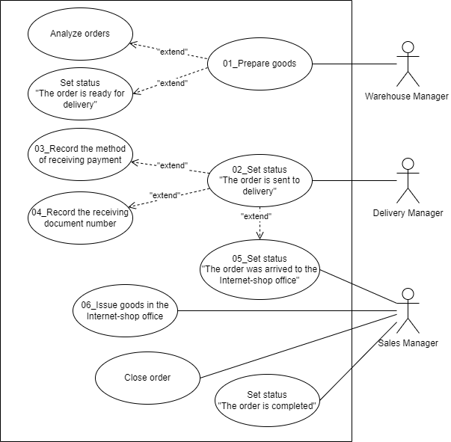3.1 Use Cases Diagram.

3.2 Опис варіантів використання в табличній формі.

|  |  |
| --- | --- |
| UC_01 | |
| Name | Prepare goods |
| Goal | Preparation of goods for transfer to the Delivery Manager |
| Actors | Warehouse Manager |
| Preconditions | The Warehouse Manager received the order; all goods from the order are in stock |
| Trigger | The Warehouse Manager analyzes the list of received orders |
| Flow of events | 1. The Warehouse Manager collects the goods from the orders’ list  2. The Warehouse Manager packes goods in boxes  3. The Warehouse Manager brings ready orders to the transfer point  4. The Warehouse Manager sets up the status of orders in System as “Orders are ready for delivery” |
| Post-conditions or  Guarantees | The goods are ready to be handed over to the Delivery Manager |

|  |  |
| --- | --- |
| UC_02 | |
| Name | Set status “The order is sent to delivery” |
| Goal | The Delivery Manager delivers the goods |
| Actors | Delivery Manager |
| Preconditions | The Warehouse Manager prepared the goods from the orders for handover to the Delivery Manager |
| Trigger | The Delivery Manager arrived to the warehouse |
| Flow of events | 1. The Delivery Manager pick up orders in the warehouse  2. The Delivery Manager sets the status of orders in System as “Orders are sent to delivery”  3. The Delivery Manager delivers the goods depending on the delivery method indicated by the Client in the order:     1.1. To the Client's address     1.2. To the Post Office     1.3. To the Internet-shop office |
| Post-conditions or  Guarantees | Orders are sent for delivery |
| UC_03 | |
| Name | Record the method of receiving payment |
| Goal | The Delivery Manager delivers the goods to the Client’s address |
| Actors | Delivery Manager |
| Preconditions | The delivery was ordered to the Client’s address |
| Trigger | The Delivery Manager choose the order in the list and check the delivery method |
| Flow of events | 1. The Delivery Manager delivers the order to the Client  2. The Delivery Manager records in the System the method of receiving payment (cash or settlement by payment card)  3. The Delivery Manager provides the Sales Manager with information about the completed delivery  4. The Sales Manager closes the order in the System  and sets the status of the order to "Completed" |
| Post-conditions or  Guarantees | The orders are delivered to the Clients |

|  |  |
| --- | --- |
| UC_04 | |
| Name | Record the receiving document number |
| Goal | The Delivery Manager delivers the goods to the Post Office |
| Actors | Delivery Manager, Post Office Manager |
| Preconditions | The delivery was ordered to the Post Office |
| Trigger | The Delivery Manager choose the order in the list and check the delivery method |
| Flow of events | 1. The Delivery Manager delivers the goods to the Post Office  2. The Post Office Manager creates a receipt document that confirms that the order has been delivered to the Post Office  3. The Delivery Manager records the document number in the System confirming receipt of the goods by the Post Office Manager  4. The Delivery Manager provides the Sales Manager with information about the completed delivery  5. The Sales Manager closes the order in the System and sets the status of the order to "Completed" |
| Post-conditions or  Guarantees | The orders are delivered to the Post Office, from where they go directly to Clients |
| UC_05 | |
| Name | Set status "The order was arrived to the Internet-shop office" |
| Goal | The Delivery Manager delivers the goods to the office of the Internet-shop |
| Actors | Delivery Manager, Sales Manager |
| Preconditions | The delivery was ordered to the Internet-shop office |
| Trigger | The Delivery Manager choose the order in the list and check the delivery method |
| Flow of events | 1. The Delivery Manager delivers the order to the Internet-shop office  2. The Sales Manager accepts the orders  3. The Sales Manager sets the status of orders in System as “The order was arrived to the Internet-shop office” |
| Post-conditions or  Guarantees | The orders are delivered to the Internet-shop office |

|  |  |
| --- | --- |
| UC_06 | |
| Name | Issue goods in the Internet-shop office |
| Goal | The Sales Manager issues goods to the Client in the Internet-shop office |
| Actors | Sales Manager |
| Preconditions | The goods are delivered to the Internet-shop office |
| Trigger | The Client arrived to the Internet-shop office to pick up the order |
| Flow of events | 1. The Sales Manager prints the payment document (invoice) and hands the payment document to the Client  2. The Client makes payment at the cash desk of the Internet-shop  3. The Sales Manager hands over the goods to the Client upon payment  4. The Sales Manager closes the order in System and sets the status of the order to "Completed" |
| Post-conditions or  Guarantees | The goods are transferred to the Client |

1. 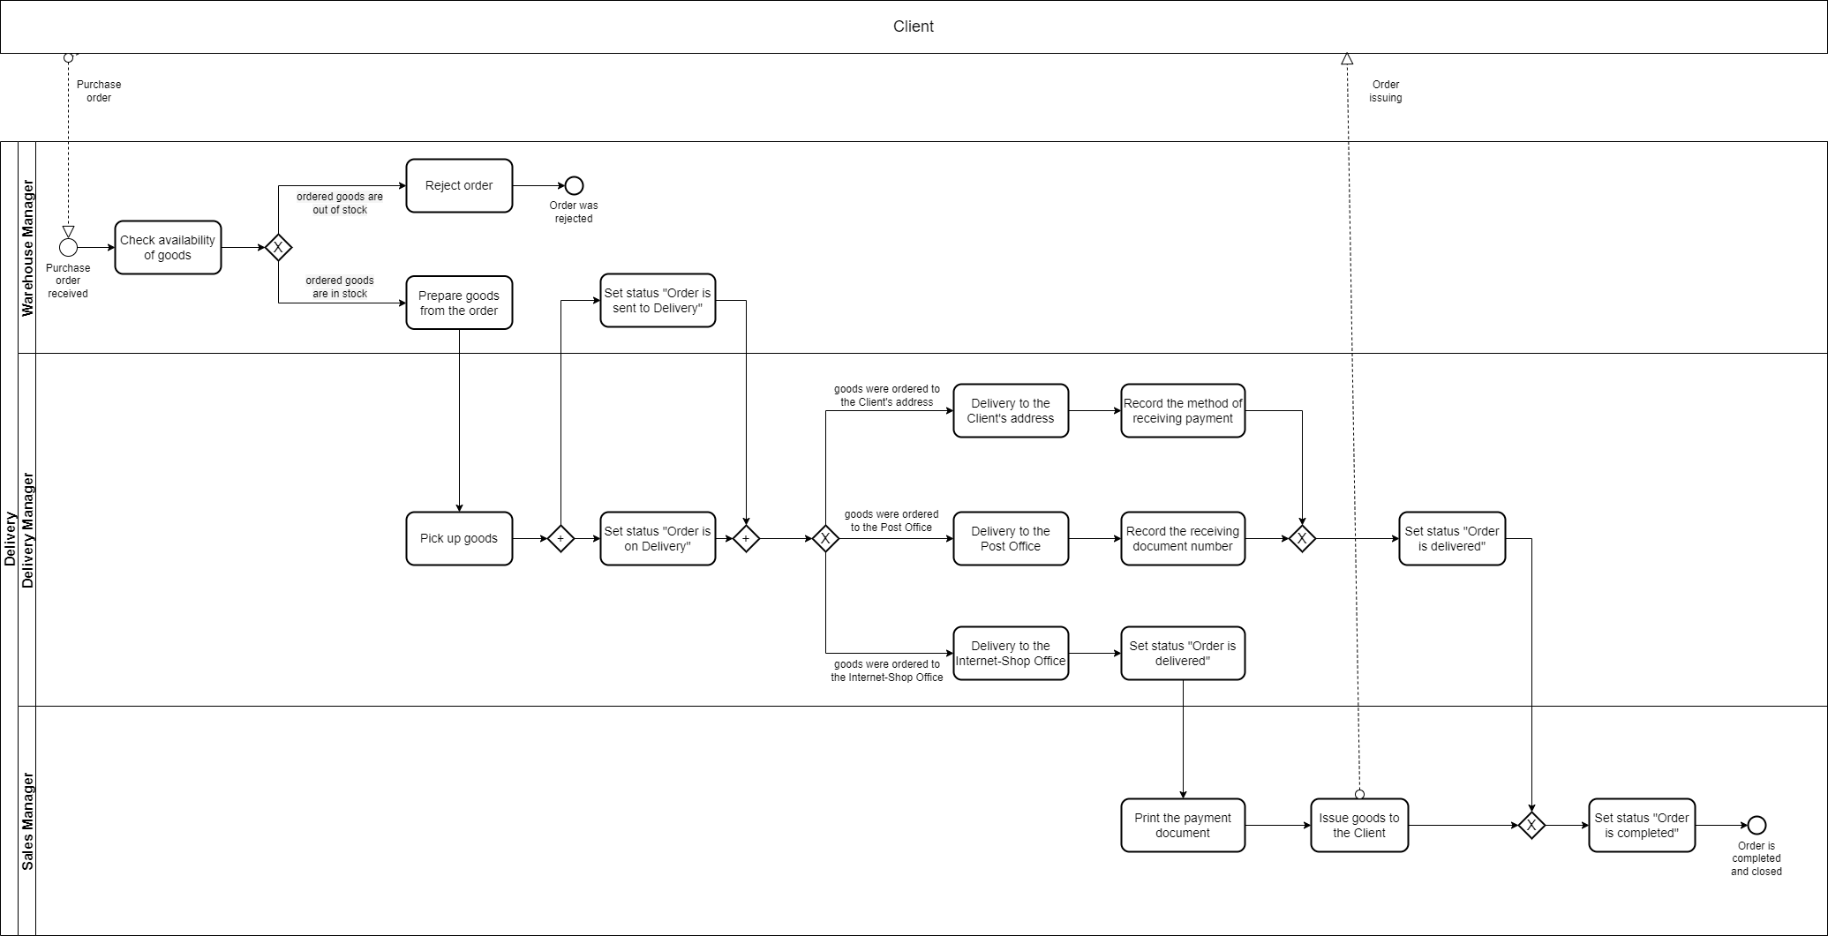**Модель Бізнес процесу (Business Process Model).**
2. **Моделі Екранних форм Бізнес процесу (Screen Forms Models).**
   1. **Екранна форма «Замовлення для доставки».**

5.1.1. Графічна схема екранної форми.

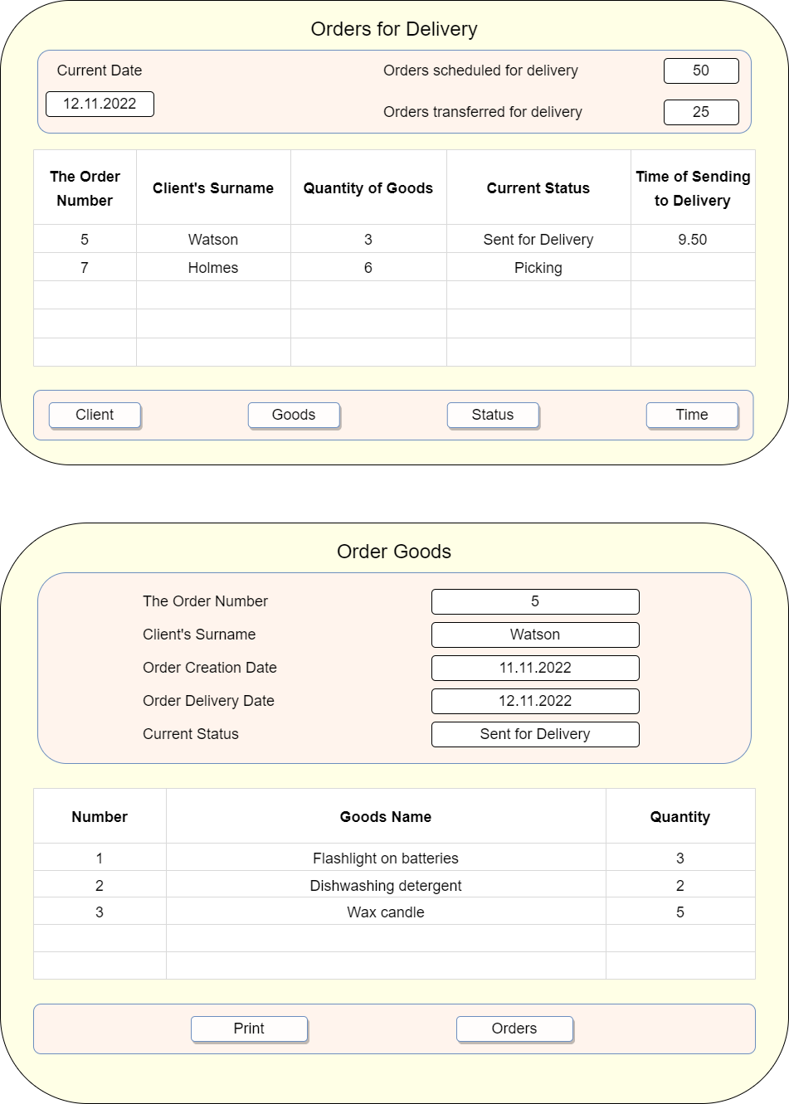

5.1.2. Текстовий опис екранної форми.

5.1.2.1. Правила формування значень полів на екранній формі.

|  |  |  |
| --- | --- | --- |
| **Screen Form Field Name** | **Database Table Name** | **Database Table Field Name** |
| Current Date | Order | DeliveryDate |
| The Order Number | Order | OrderID |
| Client’s Surname | Client | ClientSurname |
| Quantity of Goods | Order | QuantityOfGoods |
| Current Status | Order | Status |
| Time of Sending to Delivery | Order | TransferToDeliveryTime |

*Правила відбору певних рядків із таблиць Бази Даних:*

Only those rows of the “Order” table whose “DeliveryDate” field value corresponds to the current date are displayed in the “Orders for Delivery” Screen Form, and this date is displayed in the “Current Date” field of the Screen Form.

The value of the “Client's Surname” field of the Screen Form is set for each line of the Form as the value of the “ClientSurname” field of the “Client” table of the record, in which the value of the “ClientID” field is equal to the value of the field of the same name in the “Order” table, which corresponds to the selected line of the Screen Form.

The value of the field “Orders scheduled for delivery” of the Screen Form is displayed as the number of rows of the table “Order” of the Database, in which the value of the field “DeliveryDate” is equal to the current date.

The value of the “Orders transferred to delivery” field of the Screen Form is displayed as the number of rows of the “Order” table of the Database, in which the value of the “DeliveryDate” field is equal to the current date, and the “Status” field has the value “Sent for Delivery”.

5.1.2.2. Правила валідації вхідних даних.

1. Field “Client’s Surname”:

* Cannot be empty;
* Contains no more than 20 characters.

1. Field “Time of Sending to Delivery”:

* Is entered in format <Hour>.<Minutes>.

1. If user entered incorrect data, a warning message will be displayed on the Screen Form. Message consists of:

* The name of field, in which incorrect data was entered;
* Characteristics of the detected error;
* User action to continue the workflow in Screen Form – “The date is incorrect. Click OK to try again.”

5.1.2.3. Дії, що виконуються при активації команд.

1. Selecting an active order:

* Is the default command;
* The command is activated when the user presses the mouse button while the mouse cursor is on one of the fields of a specific Order. Activation of the Order is confirmed by highlighting the full line with the Order;
* Sets the Order for which the commands (“Client”, “Goods”, “Status” and “Time”), given in the command part of the Screen Form, will be executed.

1. Selecting a field for data entry:

* The command is activated when the user double-clicks the mouse button while the mouse cursor is on the field window for which values can be entered;
* Opens a field window for entering a value.

1. Finish entering the field value:

* The command is activated when the user presses the “Enter” key in the field value input window;
* Closes the input field window, verifies that the input is correct, and saves new/changed data to the Database.

1. “Client”:

* This command switches to the “Client” Screen Form, which presents the information about the Client of the active Order.

1. “Goods”:

* This command switches to the “Order Goods” Screen Form, which displays the list of Goods of the active Order.

1. “Status”:

* This command opens the window of the “Status” field of the Screen Form, in which the Status of the active Order can be changed to one of the possible statuses;
* The new Status will be saved in the “Status” field of the “Order” table in the Database in a row whose value of the “OrderID” field is equal to the value of the corresponding field of the active Order of the Screen Form.

1. “Time”:

* This command opens the window of the “Time of Sending to Delivery” field of the Screen Form for entering the value in the line with the active Order;
* This command can be executed only for those Orders that have not been sent for delivery;
* The entered Time value will be saved in the “TransferToDeliveryTime” field of the “Order” table in the Database in a row whose value of the “OrderID” field is equal to the value of the corresponding field of the active Order of the Screen Form.

**5.2 Екранна форма «Товари Замовлення».**

5.2.1. Графічна схема екранної форми.

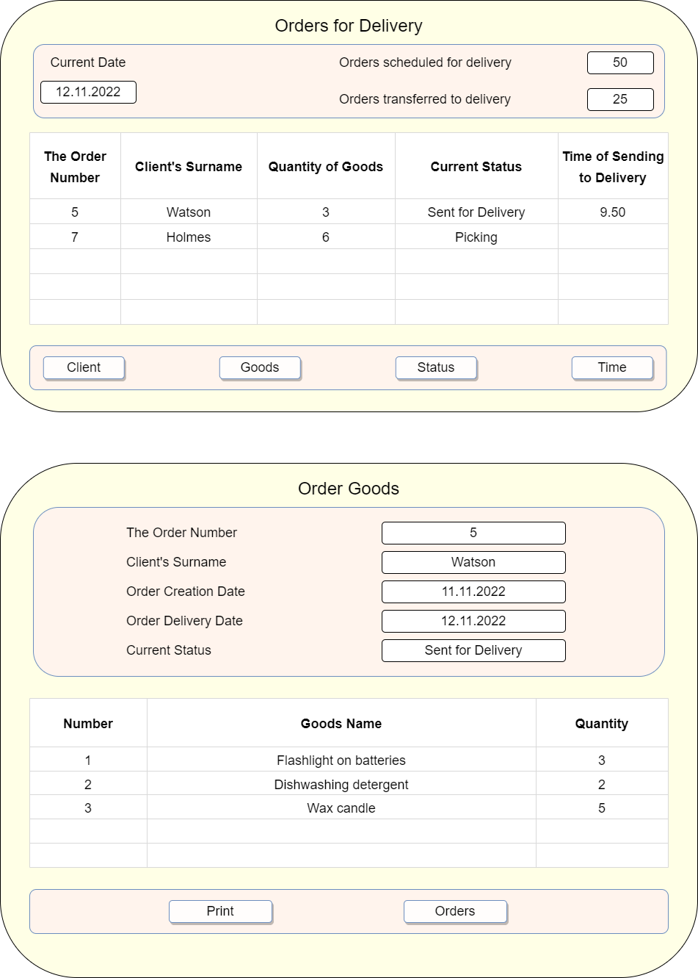

5.2.2. Текстовий опис екранної форми.

5.2.2.1. Правила формування значень полів на екранній формі.

|  |  |  |
| --- | --- | --- |
| **Screen Form Field Name** | **Database Table Name** | **Database Table Field Name** |
| The Order Number | Order | OrderID |
| Client’s Surname | Client | ClientSurname |
| Order Creation Date | Order | CreationDate |
| Order Delivery Date | Order | DeliveryDate |
| Current Status | Order | Status |
| Goods Name | Good | GoodName |
| Quantity | OrderGoods | Quantity |

*Правила відбору певних рядків із таблиць Бази Даних:*

From the “Order” table of the Database, data is selected only from the row in which the value of the “OrderID” field is equal to the value of the “The Order Number” field of the active Order of the “Orders for Delivery” Screen Form, from which the transition to this Form was made.

The “Client's Surname” field is filled in as the value of the “ClientSurname” field of the “Client” table of the Database in a row that has the value of the “ClientID” field equal to the value of the field of the same name of the above-mentioned row of the “Order” table.

Only those rows are selected from the “OrderGoods” table of the Database, in which the value of the “OrderID” field is equal to the value of the field of the same name of the above-mentioned row of the “Order” table.

The value of the “Goods Name” field of the Screen Form is set for each line of the Form as the value of the “GoodName” field of the “Good” table of the Database of the record, in which the value of the “GoodID” field is equal to the value of the field of the same name in the “OrderGoods” table, which corresponds to the selected line of the Screen Form.

The “Number” field of the Screen Form is generated automatically as a counter.

5.2.2.2. Правила валідації вхідних даних.

The Screen Form “Order Goods” does not provide an opportunity to change the values of the Database fields.

5.2.2.3. Дії, що виконуються при активації команд.

1. “Print”:

* This command prints the Order in the form of a document with information about the Order and a list of the ordered Goods.

1. “Orders”:

* This command switches to the previous Screen Form from which this Form was called by the “Goods” command.

1. **Моделі даних Бізнес процесу (Data Models).**

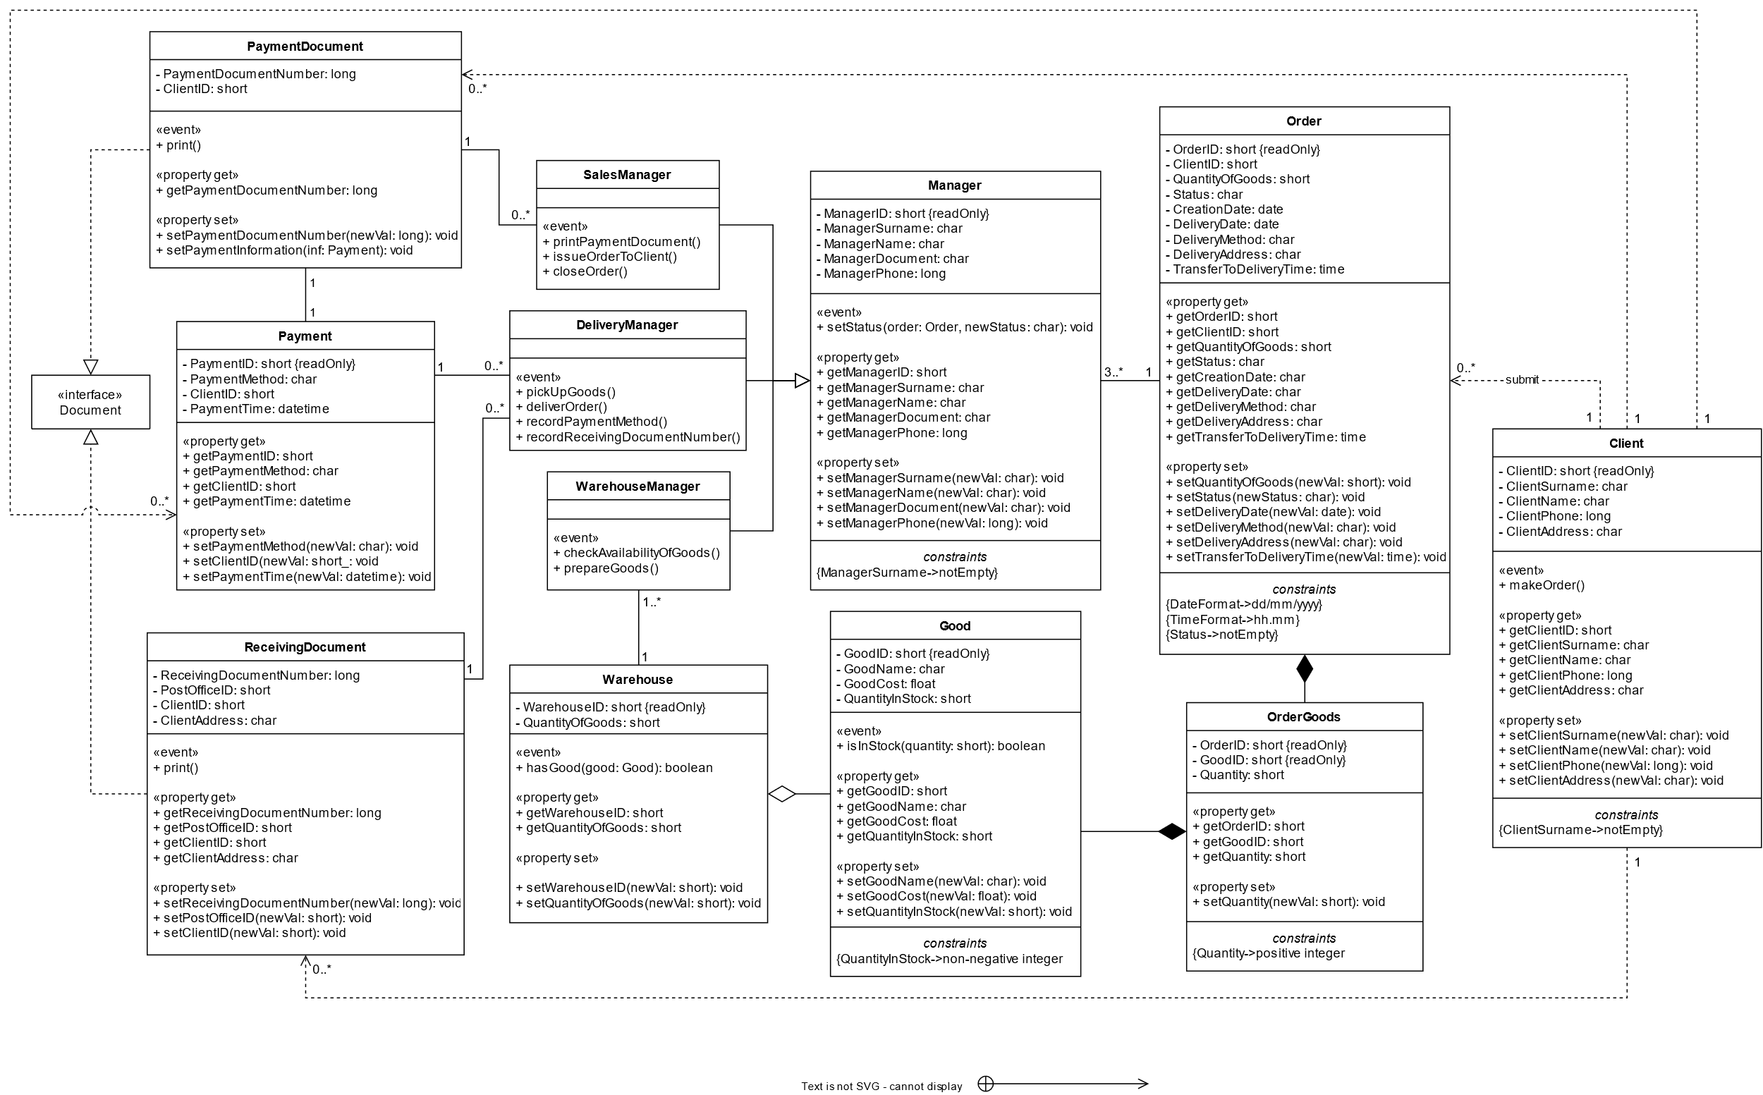6.1. Діаграма класів.

6.2. Логічні моделі усіх інформаційних об’єктів.

|  |  |  |  |  |
| --- | --- | --- | --- | --- |
| Client | | | | |
| Number | Field Name | Key | Format | Length |
| 1 | ClientID | K | Decimal | 4.0 |
| 2 | ClientSurname |  | Char | 20 |
| 3 | ClientName |  | Char | 20 |
| 4 | ClientPhone |  | Decimal | 12.0 |
| 5 | ClientAddress |  | Char | 50 |

|  |  |  |  |  |
| --- | --- | --- | --- | --- |
| Order | | | | |
| Number | Field Name | Key | Format | Length |
| 1 | OrderID | K | Decimal | 4.0 |
| 2 | ClientID |  | Decimal | 4.0 |
| 3 | QuantityOfGoods |  | Decimal | 3.0 |
| 4 | Status |  | Char | 50 |
| 5 | CreationDate |  | Date | – |
| 6 | DeliveryDate |  | Date | – |
| 7 | DeliveryMethod |  | Char | 20 |
| 8 | DeliveryAddress |  | Char | 50 |
| 9 | TransferToDeliveryTime |  | Datetime | – |

|  |  |  |  |  |
| --- | --- | --- | --- | --- |
| OrderGoods | | | | |
| Number | Field Name | Key | Format | Length |
| 1 | OrderID | K | Decimal | 4.0 |
| 2 | GoodID | K | Decimal | 4.0 |
| 3 | Quantity |  | Decimal | 3.0 |

|  |  |  |  |  |
| --- | --- | --- | --- | --- |
| Good | | | | |
| Number | Field Name | Key | Format | Length |
| 1 | GoodID | K | Decimal | 4.0 |
| 2 | GoodName |  | Char | 50 |
| 3 | GoodCost |  | Decimal | 5.2 |
| 4 | QuantityInStock |  | Decimal | 3.0 |

|  |  |  |  |  |
| --- | --- | --- | --- | --- |
| Manager | | | | |
| Number | Field Name | Key | Format | Length |
| 1 | ManagerID | K | Decimal | 4.0 |
| 2 | ManagerSurname |  | Char | 20 |
| 3 | ManagerName |  | Char | 20 |
| 4 | ManagerDocument |  | Char | 12 |
| 5 | ManagerPhone |  | Decimal | 12.0 |

|  |  |  |  |  |
| --- | --- | --- | --- | --- |
| Warehouse | | | | |
| Number | Field Name | Key | Format | Length |
| 1 | WarehouseID | K | Decimal | 4.0 |
| 2 | QuantityOfGoods |  | Decimal | 3.0 |

|  |  |  |  |  |
| --- | --- | --- | --- | --- |
| Payment | | | | |
| Number | Field Name | Key | Format | Length |
| 1 | PaymentID | K | Decimal | 4.0 |
| 2 | PaymentMethod |  | Char | 20 |
| 3 | ClientID |  | Decimal | 4.0 |
| 4 | PaymentTime |  | Datetime | – |

|  |  |  |  |  |
| --- | --- | --- | --- | --- |
| PaymentDocument | | | | |
| Number | Field Name | Key | Format | Length |
| 1 | PaymentDocumentNumber | K | Decimal | 8.0 |
| 2 | ClientID |  | Decimal | 4.0 |

|  |  |  |  |  |
| --- | --- | --- | --- | --- |
| ReceivingDocument | | | | |
| Number | Field Name | Key | Format | Length |
| 1 | ReceivingDocumentNumber | K | Decimal | 8.0 |
| 2 | PostOfficeID |  | Decimal | 4.0 |
| 3 | ClientID |  | Decimal | 4.0 |
| 4 | ClientAddress |  | Char | 50 |

1. **User Stories Екранних форм (User Stories Descriptions).**

7.1. Обрана Екранна Форма.

User Stories будуть розроблені для екранної форми «Замовлення для доставки».

7.2. Номери та назви Головних User Stories.

IS-01. Screen form “Orders for Delivery” – UI and Commands,

IS-04. Screen form “Order Goods” – UI and Commands.

* 1. Опис основних User Stories.

**7.3.1. IS-01. Screen form “Orders for Delivery” – UI and Commands:**

* *Statement of Value*

|  |  |
| --- | --- |
| As a | Delivery Manager |
| I want to | be able to view in the System the number and content of orders for the current date. |
| So that | I will be able to deliver goods to customers in accordance with orders. |

* *Detailed Description of Requirements*

1. Requirements for the interface of the Screen Form



**1**

**2**

**3**

**4**

**5**

**6**

**7**

**8**

**9**

**10**

**11**

**12**

**13**

1. Requirements for initial filling of the Screen Form fields with data from tables

***1*** – “Current Date” is set by the System automatically according to the current server calendar date.

***2*** – “Orders scheduled for delivery” is set as the number of rows (orders) of the table “Order” of the Database, which have “DeliveryDate” field value equal to the current server calendar date.

***3*** – “Orders transferred for delivery” is set according to the number of rows (orders) of the table “Order” of the Database, in which the value of the “DeliveryDate” field is equal to the current server calendar date, and the “Status” field has the value “Sent for Delivery”.

***4*** – The values of the “The Order Number” column fields of the Screen Form is set as the values of the “OrderID” field of the table “Order” of the Database, in which the “DeliveryDate” field’s value is equal to the current server calendar date.

***5*** – The value of the “Client's Surname” field of the Screen Form is set for each line of the Form as the value of the “ClientSurname” field of the “Client” table of the record, in which the value of the “ClientID” field is equal to the value of the field of the same name in the “Order” table, which corresponds to the selected line of the Screen Form.

Values of the fields number 6, 7 and 8 gets from the table “Order” of the Database from the record, in which the value of the field “OrderID” is equal to the value of the “The Order Number” field of the selected line of the Screen Form according to the following rules:

***6*** – “Quantity of Goods” is the field of the Screen Form that corresponds to the field “QuantityOfGoods” of the “Order” table of the Database.

***7*** – The value of the field “Current Status” of the Screen Form is set as the value of the field “Status” of the corresponding order from the “Order” table of the Database; can later be changed by the user (Warehouse Manager, Delivery Manager or Sales Manager) according to the current status of the delivery and is available for modification by clicking this field or the “Status” command.

***8*** – “Time of Sending to Delivery” is the field of the Screen Form that corresponds to the field “TransferToDeliveryTime” of the corresponding order from the table “Order” of the Database; can later be changed by the user (Warehouse Manager) according to the time, when the Delivery Manager picked up the order goods, and is available to change after clicking this field or the “Time” command.

1. Requirements for execution of commands selected by the user

***9*** – The Row of the Screen Form table, after clicking on which commands become available for the selected order.

***10*** – “Client” is the command that, after clicking on it, opens new Screen Form “Client”; available only when one of the orders was selected (by clicking on one of the rows in the Screen Form table); calls the IS-06. Screen form “Client” – UI and Commands.

***11*** – “Goods” is the command that, after clicking on it, opens new Screen Form “Order Goods”; available only when one of the orders was selected (by clicking on one of the rows in the Screen Form table); calls the IS-04. Screen form “Order Goods” – UI and Commands.

***12*** – “Status” is the command, after clicking on which the field “Current Status” become available to entering or changing; available only when one of the orders was selected (by clicking on one of the rows in the Screen Form table); calls the IS-02. Screen form “Orders for Delivery” – Entering Values.

***13*** – “Time” is the command, after clicking on which the field “Time of Sending to Delivery” become available to entering or changing; available only when one of the orders was selected (by clicking on one of the rows in the Screen Form table); calls the IS-02. Screen form “Orders for Delivery” – Entering Values.

* *Acceptance criteria*

IS-01 – AC-001

|  |  |
| --- | --- |
| AC Name | Execution of the command “Client” |
| Given | The row with the order on the Screen Form table was selected by user (by clicking on one of the rows in the Screen Form table). |
| When | The user clicks on the command “Client”. |
| Then | IS-06 is called, the “Client” Screen Form opens, which displays information about the client who placed the selected order. |

IS-01 – AC-002

|  |  |
| --- | --- |
| AC Name | Execution of the command “Goods” |
| Given | The row with the order on the Screen Form table was selected by user (by clicking on one of the rows in the Screen Form table). |
| When | The user clicks on the command “Goods”. |
| Then | IS-04 is called, the “Order Goods” Screen Form opens, which displays the list of goods of the selected order. |

IS-01 – AC-003

|  |  |
| --- | --- |
| AC Name | Execution of the command “Status” |
| Given | The row with the order on the Screen Form table was selected by user (by clicking on one of the rows in the Screen Form table). |
| When | The user clicks on the command “Status”. |
| Then | IS-02 is called, entering and changing the value of the field “Status” became available. |

IS-01 – AC-004

|  |  |
| --- | --- |
| AC Name | Execution of the command “Time” |
| Given | The row with the order on the Screen Form table was selected by user (by clicking on one of the rows in the Screen Form table). |
| When | The user clicks on the command “Time”. |
| Then | IS-02 is called, entering and changing the value of the field “Time of Sending to Delivery” became available. |

* *Linked Issues*

IS-01 is the main User Story on that Screen Form and calls three another User Stories:   
- IS-02. Screen form “Orders for Delivery” – Entering Values,

- IS-04. Screen form “Order Goods” – UI and Commands,

- IS-06. Screen form “Client” – UI and Commands.

**7.3.2 IS-02. Screen form “Orders for Delivery” – Entering Values:**

* *Statement of Value*

|  |  |
| --- | --- |
| As a | Warehouse Manager/Delivery Manager/Sales Manager |
| I want to | be able to change in the System the status of the delivery and the time of sending the orders to delivery. |
| So that | I will be able to update information for another users. |

* *Detailed Description of Requirements*

***1)*** Adding new orders for delivery to the Screen Form is done automatically by the System by comparing the server’s current calendar date and the delivery date specified in the order. If the order meets this criterion, it will be automatically added to the Screen Form table at the beginning of a new working day. Additionally, the table may include orders that for some reason were not delivered the day before with a change in the delivery date (in the Screen Form table, they are no different from other orders). This option is not available for users such as Warehouse Manager, Delivery Manager and Sales Manager.

***2)*** Entering or changing the value in the field “Current Status” is available after selecting the row with the required order and clicking on the “Status” command. The user (Warehouse Manager, Delivery Manager or Sales Manager) can edit the value in this field by selecting one or another value from the drop-down list with the following options:

* Picking;
* Sent for Delivery;
* On Delivery;
* Delivered;
* Completed.

To confirm the status change, the user must press the “Enter” key on the keyboard. After that the new value will be saved in the “Status” field of the “Order” table of the Database in the record corresponding to the selected order and updated in the Screen Form table.

***3)*** Entering or changing the value in the field “Time of Sending to Delivery” is available after selecting the row with the required order and clicking on the “Time” command. The user (Warehouse Manager) can edit the value in this field by entering the time from the keyboard in a special format. After entering, the user must press the “Enter” key on the keyboard to confirm the action. Then the input will be validated by calling another User Story (IS-03. Screen form “Orders for Delivery” – Verification and Validation) and sending there:

* the name of this field in the “Order” table of the Database (“TransferToDeliveryTime”),
* the entered value, and
* out value for recording the check result.

***3.1)*** If the result of IS-03 is “true”, the new value will be saved in the “TransferToDeliveryTime” field of the “Order” table of the Database in the record corresponding to the selected order and updated in the Screen Form table.

***3.2)*** If the result of IS-03 is “false”, User Story IS-02 will be called one more time. This action will be repeated until the result of IS-03 is “true”.

* *Acceptance criteria*

IS-02 – AC-001

|  |  |
| --- | --- |
| AC Name | Entering/changing the field “Current Status” |
| Given | The row with the order on the Screen Form table was selected by user (by clicking on one of the rows in the Screen Form table) and the command “Status” was clicked. |
| When | The user selected a new status from the drop-down list and pressed “Enter”. |
| Then | The value of the field “Status” of the corresponding row of the “Order” table of the Database is updated and saved, the value in the selected field “Current Status” of the Screen Form table is updated. |

IS-02 – AC-002

|  |  |
| --- | --- |
| AC Name | Entering/changing the field “Time of Sending to Delivery” |
| Given | The row with the order on the Screen Form table was selected by user (by clicking on one of the rows in the Screen Form table) and the command “Time” was clicked. |
| When | The user entered a new value of the time from the keyboard and pressed “Enter”. |
| Then | IS-03 is called; if the result of executing the IS-03 User Form is “true”, the value of the field “TransferToDeliveryTime” of the corresponding row of the “Order” table of the Database is updated with the entered value and saved, and the value in the selected field “Current Status” of the Screen Form table is updated; otherwise, User Story IS-02 is called again. |

* *Linked Issues*

IS-02 is the subsidiary User Story on that Screen Form and calls one another User Story:

- IS-03. Screen form “Orders for Delivery” – Verification and Validation.

IS-02 depends on IS-01. Screen form “Orders for Delivery” – UI and Commands.

**7.3.3. IS-03. Screen form “Orders for Delivery” – Verification and Validation:**

* *Statement of Value*

|  |  |
| --- | --- |
| As a | Warehouse Manager/Delivery Manager/Sales Manager |
| I want to | be sure that the information in the Database and on the Screen Form is correct. |
| So that | no errors will occur during the operation of the System. |

* *Detailed Description of Requirements*

***1)*** While input name of field is “TransferToDeliveryTime”, the entered value is checking for format compliance:

* Time must be presented in <hour>.<minutes> format;
* <hour> must be between 0 and 23;
* <minutes> must be between 0 and 59;

***2)*** If the entered value does not satisfy at least one requirement, the out value will be “false”. The message about entering incorrect data will be showed on the Screen Form. That message contains:

* The name of the field, in which incorrect data was entered;
* Requirement that was violated (Requirements that were violated);
* Action form with text message “The date is incorrect. Click OK to try again.”

***3)*** If the entered value satisfies all of the requirements, the out value will be “true”.

* *Acceptance criteria*

IS-03 – AC-001

|  |  |
| --- | --- |
| AC Name | Verification and Validation of the data entered in the field “TransferToDeliveryTime” in the correct format |
| Given | The user has entered time in correct format in compliance with all requirements. |
| When | The user presses “Enter” to confirm. |
| Then | The User Story IS-02. Screen form “Orders for Delivery” – Entering Values receives out value “true” and completes the task successfully. |

IS-03 – AC-002

|  |  |
| --- | --- |
| AC Name | Verification and Validation of the data entered in the field “TransferToDeliveryTime” in wrong format |
| Given | The user entered time in wrong format. |
| When | The user presses “Enter” to confirm. |
| Then | The message with information about the error appears in the Screen Form; the User Story IS-02. Screen form “Orders for Delivery” – Entering Values receives out value “false”. |

* *Linked Issues*

IS-03 is the subsidiary User Story on that Screen Form and does not call any other User Story.

IS-03 depends on IS-02. Screen form “Orders for Delivery” – Entering Values.